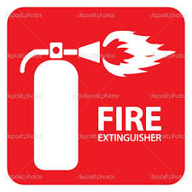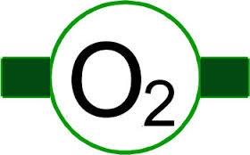

**Early Labor Lounge:**

Major Damage:

_______________________________________________________________________________________________________________

Ok to Enter? Y/N

Patient: Y/N # of Visitors: ___________

OR B

OR A

Labor Rooms

1-10

OR C

PACU, 11A, & US

**OR C:**

Major Damage: ______________________________  
________________________________________________________________________ Ok to Enter? Y/N RNs & Staff: _________________________________

Patient: Y/N # of Visitors: _________________

**OR B:**

Major Damage: __________________  
_________________________________________________ Ok to Enter? Y/N RNs & Staff: _____________________

Patient: Y/N # of Visitors: _______

**Code**

**Cart**

**Front Desk:**

Major Damage: ______________________________

____________________________ Ok to Enter?: Y/N

Staff: _______________________________________

**Tube  
Station**

**Disaster  
Binder**

**Disaster  
Boxes**

**Code**

**Cart**

**Supply Room:**

Major Damage:

_______________________

Ok to Enter? Y/N

**Anesthesia Tech Rm:**

Major Damage:

_______________________

Ok to Enter? Y/N

Staff: __________________

**OR Tech Room:**

Damage: ______________

Ok to Enter? Y/N

Staff: __________________

**Utility Room:**

Damage: ______________

Ok to Enter? Y/N

**Exam Room:**

Major Damage:

_______________________  
Ok to Enter? Y/N

Patient: Y/N

# of Visitors:

**Patient Bathroom:**

Major Damage:

_______________________

Ok to Enter? Y/N

**Staff Bathroom:**

Major Damage:

_______________________

Ok to Enter? Y/N

**PACU-1:**

Major Damage:

________________________________Ok to Enter? Y/N

Patient: Y/N

# of Visitors: ___

**PACU-2:**

Major Damage:

________________________________Ok to Enter? Y/N

Patient: Y/N

# of Visitors: ___

**PACU-3:**

Major Damage:

________________________________Ok to Enter? Y/N

Patient: Y/N

# of Visitors: ___

**11A:**

Major Damage:

________________________________Ok to Enter? Y/N

Patient: Y/N

# of Visitors: ___

**Ultrasound Rm:**

Major Damage:  
________________________________

Ok to Enter? Y/N

Patient: Y/N

# of Visitors: ___

**11C:**

Major Damage:

________________________________Ok to Enter? Y/N

Patient: Y/N

# of Visitors: ___

**11B:**

Major Damage:

________________________________Ok to Enter? Y/N

Patient: Y/N

# of Visitors: ___

**Anesthesia Fellows:**(Code 44444)

Damage:  
___________ Ok to Enter?  
Y/N

Staff: ___________

**Labor Room 8:**

Major Damage: _____________________  
Ok to Enter? Y/N RN: ______________

Patient: Y/N # of Visitors: ________

**Labor Room 9:**

Major Damage: _____________________  
Ok to Enter? Y/N RN: ______________

Patient: Y/N # of Visitors: ________

**Labor Room 10:**

Major Damage: _____________________  
Ok to Enter? Y/N RN: ______________

Patient: Y/N # of Visitors: ________

**Labor Room 7:**

Major Damage: _____________________  
Ok to Enter? Y/N RN: ______________

Patient: Y/N # of Visitors: ________

**Labor Room 6:**

Major Damage: _____________________  
Ok to Enter? Y/N RN: ______________

Patient: Y/N # of Visitors: ________

**Labor Room 5:**

Major Damage: _____________________  
Ok to Enter? Y/N RN: ______________

Patient: Y/N # of Visitors: ________

**Labor Room 4:**

Major Damage:

________________________________

Ok to Enter? Y/N

RN:____________  
Patient: Y/N

# of Visitors: ___

**Labor Room 3:**

Major Damage:

________________________________

Ok to Enter? Y/N

RN:____________  
Patient: Y/N

# of Visitors: ___

**Labor Room 2:**

Major Damage:

________________________________

Ok to Enter? Y/N

RN:____________  
Patient: Y/N

# of Visitors: ___

**Labor Room 1:**

Major Damage:

________________________________

Ok to Enter? Y/N

RN:____________  
Patient: Y/N

# of Visitors: ___

**DirtyUtility  
(code 1234)  
O2 Tanks**

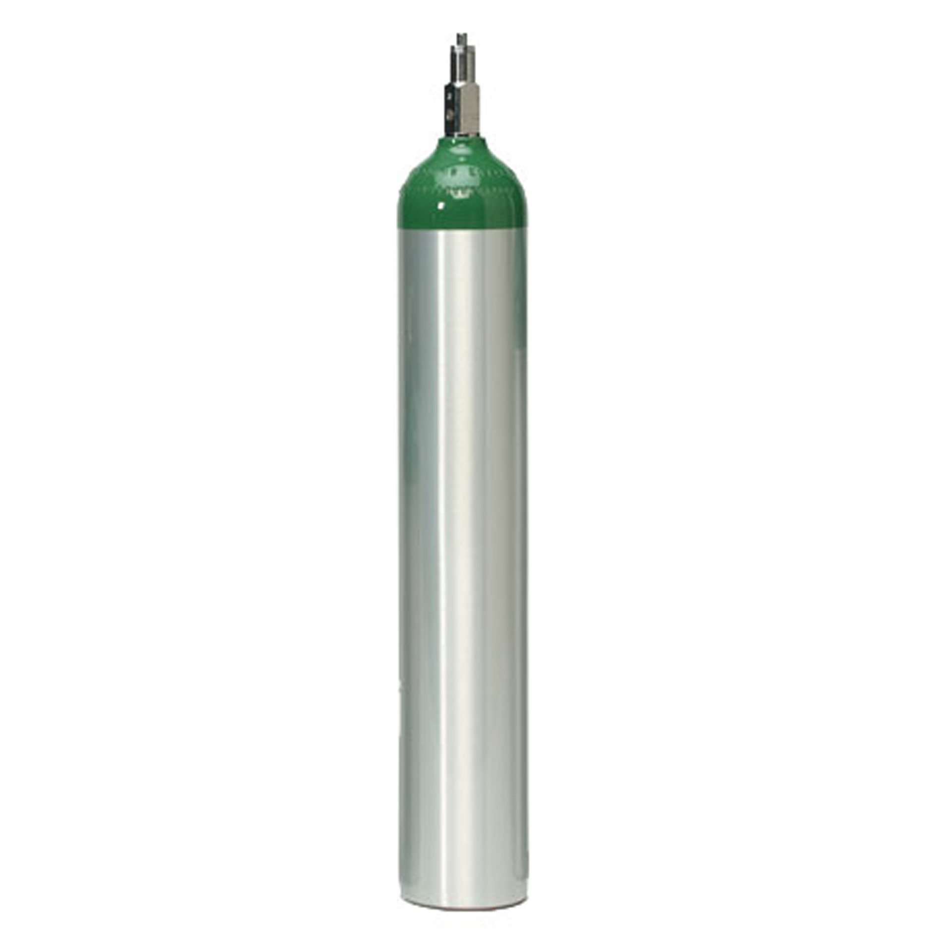

**Med Room:**

Major Damage: ____________________

___________________________________________________ Ok to Enter? Y/N

**Break Room:**

Major Damage: ______________________________

____________________________ Ok to Enter? Y/N

Staff: _______________________________________

**OR A:**

Major Damage: ____________________________________________________________________________________________________________________ Ok to Enter? Y/N   
RNs & Staff: _________________________________

Patient: Y/N # of Visitors: _______________________

Department   
Damage

Map

SHC Labor & Delivery

**Anesthesia Resident:** (Code 12768)

Damage:

___________ Ok to Enter?  
Y/N

Staff: ___________

**OB Resident:**(Code 12762)

Damage:

___________ Ok to Enter?  
Y/N

Staff: ___________

**Community MD:**(Code 12764)

Damage:  
___________ Ok to Enter?  
Y/N

Staff: ___________

**Community MD:**(Code 12766)

Damage:  
___________ Ok to Enter?  
Y/N

Staff: ___________

**Anesthesia Attending:**(Code 1234)

Damage:

___________ Ok to Enter?  
Y/N

Staff: ___________

**Men’s Locker Rm:**

(Code 84980)

Damage:  
_______________________________________  
Ok to Enter?  
Y/N

**Patient Care Mgr.:**(Rm 2774)

Damage:

___________ Ok to Enter?  
Y/N

Staff: ___________

**OB Attending:**

(Code 1234)  
Damage:

___________ Ok to Enter?  
Y/N

Staff: ___________

**OB Attending:**

(Code 1234)

Damage:  
___________ Ok to Enter?  
Y/N

Staff: ___________

**BACK HALLWAY:**

**(Offices, call-rooms, & locker rooms)**

**Women’s Locker Rm:**

(Code 84980)

Damage:  
______________________________________Ok to Enter?  
Y/N

**Ele-vator**

**Ok?:**

**Y/N**

**Bath-**

**Room**

**Ok?:**

**Y/N**