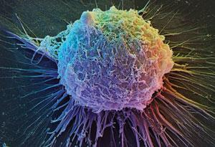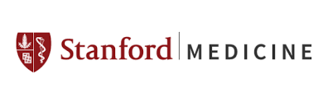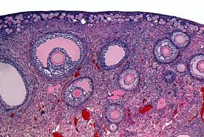
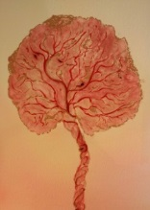

Department of Obstetrics & Gynecology

Basic Science Research

Fall 2016 HAPPY HOUR 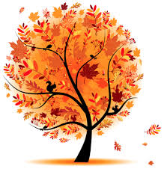

Friday, September 30th

4:00 PM – Seminar

Dr. Virginia D. Winn, will present:

Pregnancy, Placenta and Preeclampsia

Overview of the Winn lab

Lorry Lokey Stem Cell Building

Conference Room G1161

4:30 PM –Potluck

In the adjoining courtyard

~ Drinks will be provided. Please bring a favorite food to share.

Hope to see you there!!

