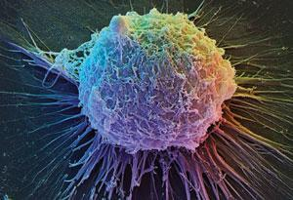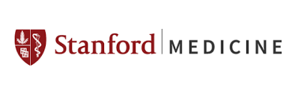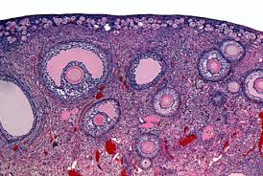

Department of Obstetrics & Gynecology

Basic Science Research

Join Us for the Spring Happy Hour!

Friday, April 29, 2016
4:00 pm

Grant Building Lab Break Room (S375)

Seminar - Vittorio Sebastiano, PhD

Assistant Professor
Department of Obstetrics and Gynecology
Stem Cells and Regenerative Medicine Institute
"Single-cell analysis and spatial reconstruction of the human blastocyst:
the Rosetta Stone to interpret early development and pluripotent stem cell biology”

~ Drinks will be provided. Please bring a favorite food to share.

Hope to see you there!!
