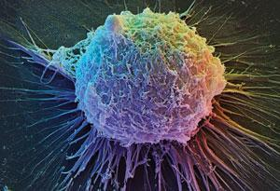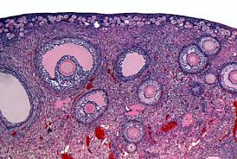

Department of Obstetrics & Gynecology Basic Science Research

Newsletter - January 11, 2016

Dear Ob/Gyn Basic Science Researchers,

Happy New Year!

I wanted to provide an update on the Grant 3rd floor lab remodel. The plans have finally been submitted to OSHPD and it is anticipated that approval will take a minimum of 4-6 months. The second round of cost estimates came in higher than expected so a portion of the project had to be scaled back for the first phase with the hope that additional money may be secured to complete before the permit expires in one year. The portions of the project that are on hold at the moment are the common tissue culture room (S321) and the Boswell portion of the Hsueh Lab (A350). We did secure more emergency power and all the -80°C will be electronically monitored.

The remodel for the Dorigo lab (S305) also came in higher than expected so temporarily on hold but still anticipated to be completed.

I also would like to initiate a quarterly newsletter for the group. So please send any announcements, any awards received, getting a grant or a paper published, etc. to Daychin (daychin@stanford.edu). This way we can all help celebrate these important accomplishments.

I would also like to initiate a quarterly “happy hour.” The first of these will be to celebrate the “newly” completed break room. It is great to see that folks are starting to use this for meetings as well for lunch and breaks. Soon there will be art work on the walls to warm it up so it feels less like a cafeteria. The first happy hour will be Friday January 22nd at 4pm in the break room (S375). Drinks will be provided but feel free to bring a snack to share.

Wishing everyone a productive and inspired 2016!!!

Virginia Winn

