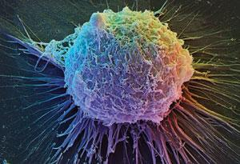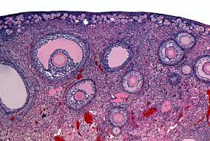

Department of Obstetrics & Gynecology

Basic Science Research Newsletter – Volume 1 Spring Issue

April 25, 2016

First Happy Hour for Ob-Gyn Researchers A Success!

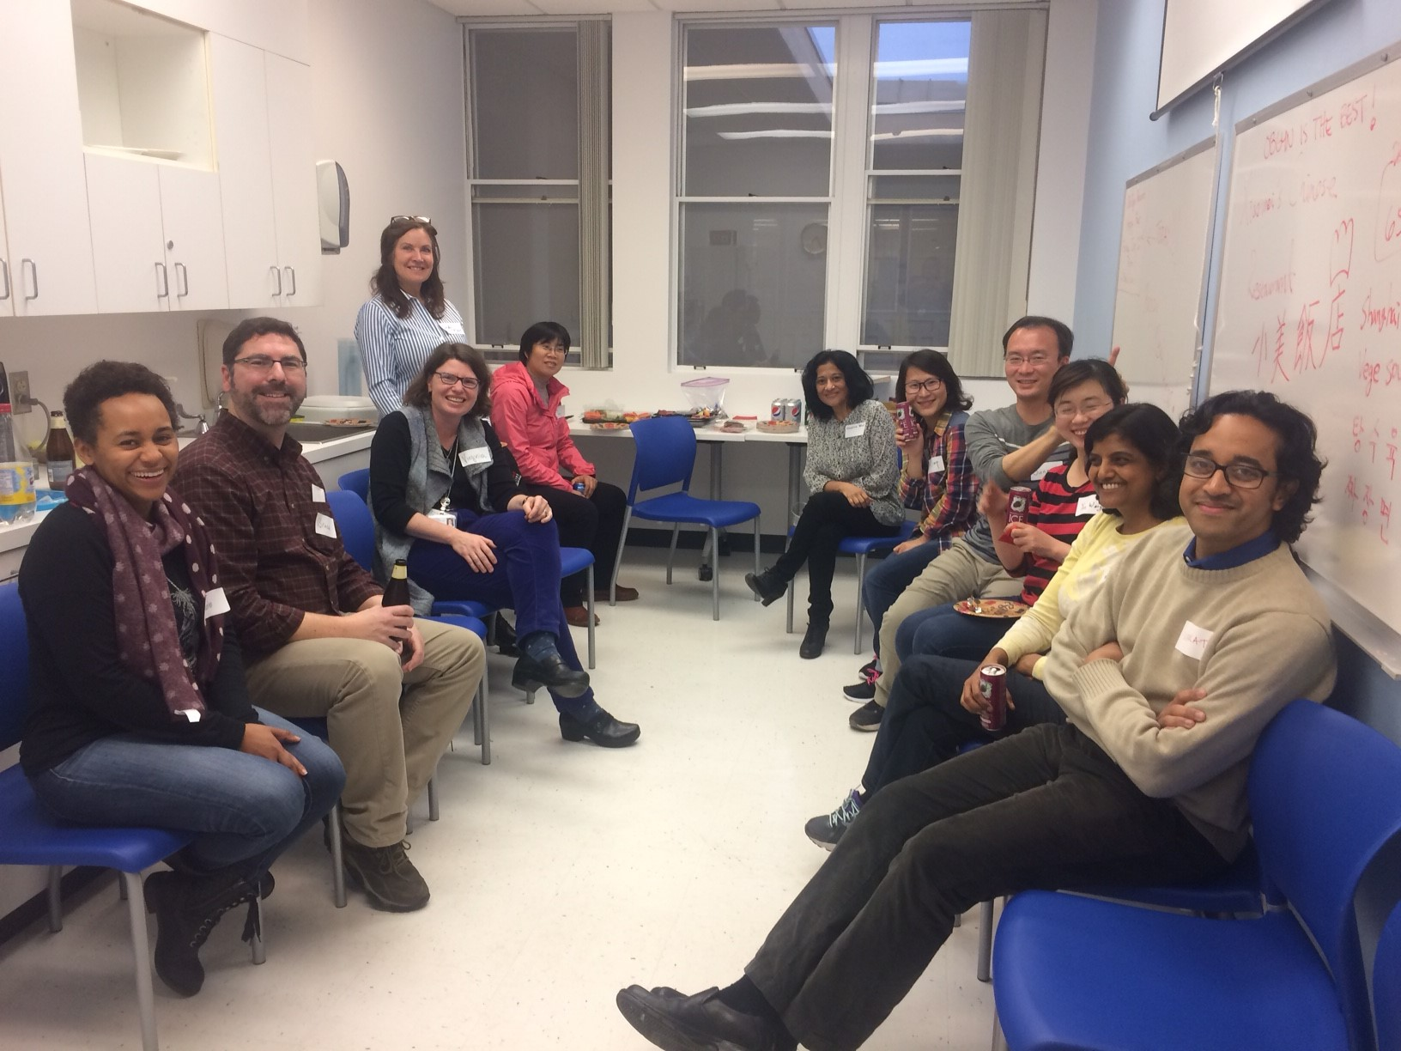

We had a nice turn out for our Winter Happy hour in March. Everyone enjoyed drinks and food that people brought to share. We will be having a happy hour every quarter. It was suggested that we also initiate a small talk at each happy hour rotating among labs, so we can all get to know what others are doing in the Department.
Join Us for the
Spring Happy Hour
Friday, April 29, 2016
4:00 pm

Grant Building Lab Break Room (S375)

(Drinks will be provided, please bring a favorite food to share.)

Speaker- Vittorio Sebastiano
"Single-cell analysis and spatial reconstruction of the human blastocyst: the Rosetta Stone to interpret early development and pluripotent stem cell biology”

Grant Building Lab Remodel Update:
The 3rd floor Grant remodel plans are in their second round of review with OSHPD
Page 1 of 3
and the contractor has been selected!! Therefore, construction may start as early as June 2016 and is expected to take 16 weeks. You will be hearing from Ellen Lewanda and Cindy Klein as details unfold.

The plan is to have all the rooms involved in the construction to have a “target” vacate date of May 16th. This includes S331, S353, S355, S361, S377, S379 (& S379A), S381, S387 (& S387A), S365 (& S365A), S373 and S383. The fume hood and freezer room will also be prepped for construction. Pediatrics is kindly loaning us some space for temporary storage, and a big thanks to everyone who has found, or created temporary space, for the frequently used equipment that is needing a home during the construction. In preparing for the remodel, the dark room will likely be out of commission by mid-May. Bruce Schaar (Dorigo Lab) and Neelima Bhat (Teng Lab) are spear-heading the effort to purchase a digital system to replace the film processor. Please provide them any input you might have on potential machines.

The contractor has assured us that the noisiest work will happen at night and on weekends. Dust will be kept to a minimum and the Chen Lab door closure will happen over a single weekend. We will keep the Grant folks posted as a more detailed timeline is known. We appreciate everyone’s patience and understanding during the construction.

Announcements:
Erinn Bruno Rankin, PhD, Assistant Professor of Gynecologic Oncology and Radiation and Cancer Biology recently received a Pilot Award on a collaborative project with Oliver Dorigo on "Targeting the hypoxic secretome in omental metastasis" from the Rivkin Center for Ovarian Cancer. Congratulations Erinn!

Vittorio Sebastiano, PhD, Assistant Professor of Obstetrics & Gynecology - Reproductive Biology is the co-lead and co-senior author of “The primate-specific noncoding RNA HPAT5 regulates pluripotency during human preimplantation development and nuclear reprogramming,” published in Nature Genetics (January 2016). His postdoctoral scholar, Jens Durruthy-Durruthy is the other lead author. They identified several noncoding RNA molecules of viral origins that are necessary for a fertilized human egg to acquire the ability to become all the cells and tissues of the body. Beautiful science guys, Congrats!
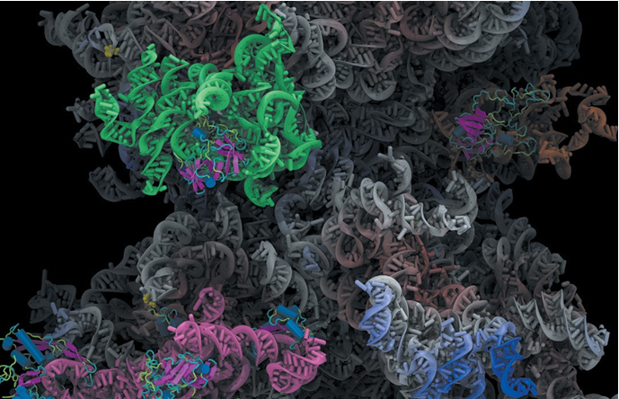
Conceptual model of a long non-coding RNA that provides structural scaffolding (grey) while binding to proteins (magenta) using highly structured domains (green, pink and orange). (Karissa Y. Sanbonmatsu)

Page 2 of 3

Other Recent Publications from Ob-Gyn researchers:

Activation of dormant follicles: a new treatment for premature ovarian failure?
Kawamura K, Kawamura N, Hsueh AJ.
Curr Opin Obstet Gynecol. 2016 Mar 26

Smooth Muscle Precursor Cells Derived from Human Pluripotent Stem Cells for Treatment of Stress Urinary Incontinence.
Wang Z, Wen Y, Li YH, Wei Y, Green M, Wani P, Zhang P, Pera RR, Chen B.
Stem Cells Dev. 2016 Mar 15;25(6):453-61.

Differential expression of human placental PAPP-A2 over gestation and in preeclampsia.
Kramer AW, Lamale-Smith LM, Winn VD.
Placenta. 2016 Jan;37:19-25.

Upcoming Dates:
Ovarian Club (Fridays at 3:30-5:00pm) - May 13th, June 10th and July 8th
Placenta Club (Mondays at noon) - May 26th, June 13th
Summer Happy Hour- July 22nd

Please send any news, announcements or photos for the next newsletter to Daychin Campbell (daychin@stanford.edu) by July 1st!

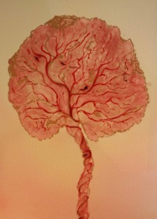

Page 3 of 3

